**Project Report**

Project name: Grocery Management System

**Group Members:**

Srikanth Guduri (700741216)

Vineeth Reddy Anugu (700741265)

Sindhu Burra (700734353)

Sirisha Reddiroutu (700741117)

**Project Description:**

Grocery store management is a very important tool for every store to keep a record of all their

data and use this information for business purposes. Most importantly, it is used to maintain

store inventory records and customer details. Online grocery shopping is a great way to get the

food your customers need without having to go to the grocery store and order it at any time of

the day. No need to check store opening hours or fret as they reorder shelves. Online grocery

services have an easy-to-navigate app that customers can use on the go. With just a few

buttons, they can order groceries, pay the total amount online using card or can pay cash when

the groceries are delivered to their doorstep by the employees. If the customers don’t like the

groceries or the food is not fresh, then they can return the products back to the store.

**Database Description:**

The user can -

1. View groceries  
2. Register and Login  
3. Order groceries  
4. Return groceries  
5. View order history

The admin can -

1. Login  
2. Create a new product  
3. Manage orders  
4. View orders list

Payment methods: Credit card, Debit card  
Payment status: Success, Failed, Refunded

Order status: Cancelled, Confirmed

Collections: Payment, user, order, product, product_order

**Mongo DB Database Model:**

Since we are using the Mongo DB database model, we can embed the related data with a single document or a structure. Embedded data models allow applications to store related pieces of information in the same database record. Data is stored in the form of Document-based Store in JSON format. All data is stored in a document.

There are the collections:

* payment
* user
* order
* product_order
* product

**Database diagram:**

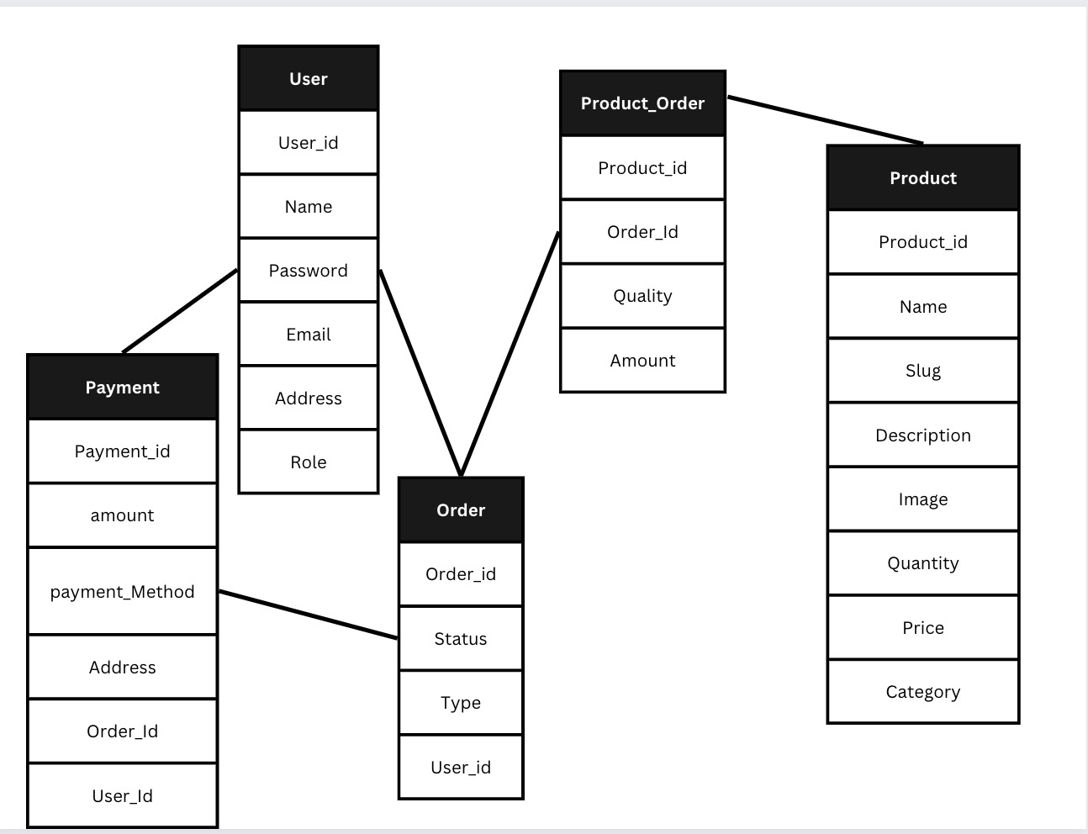

**Sample Data:**

Collections:

**Order:**

**Payment:**

**Product:**

**Product_order:**

**User:**

**User Interface & Forms:**

Home Page:

Register

Order History :

Cart:

Admin dashboard

Manage orders (admin)

Manage Product (admin)

Add new product (admin):

**No SQL commands:**

**Create Order Query**

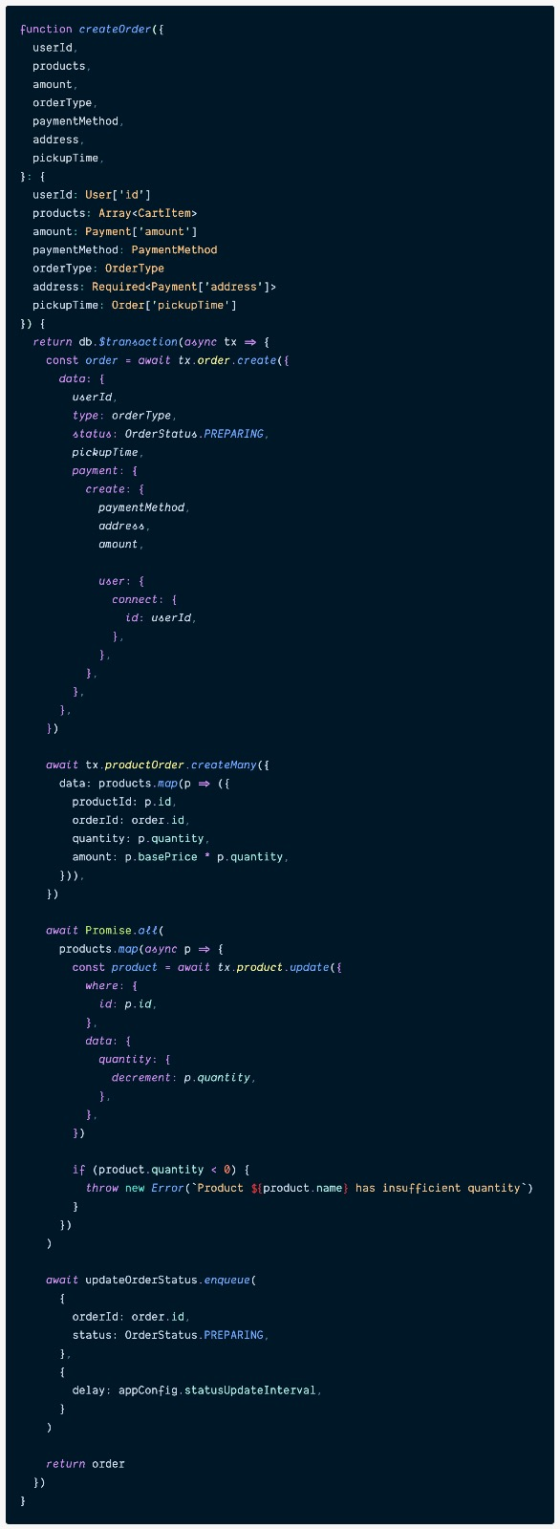

**Get Order Query:**

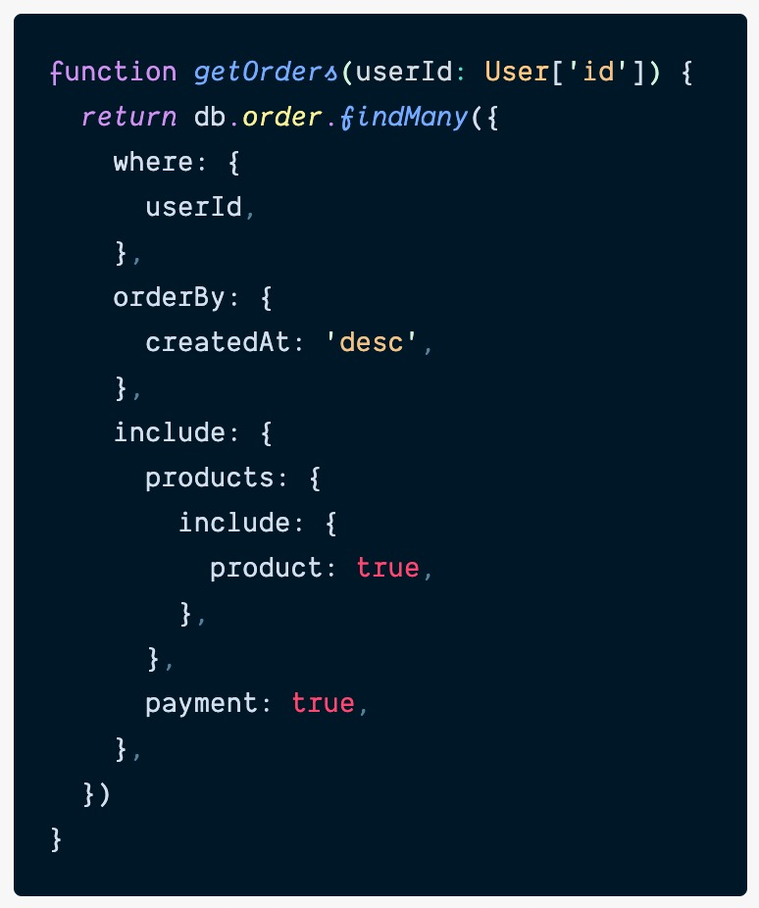

**Cancel Order Query:**

**Get All Orders Query:**

**Get All Products Query:**

**Get User Query:**

**Create User Query:**

**Verify Login Query:**

**Source Codes:**

Attached in the zip folder alongside all the libraries used.

**Participation:**

1. Srikanth Guduri – API integration in frontend
2. Vineeth Reddy Anugu- API
3. Sindhu Burra – Mongodb shell queries
4. Sirisha Reddiroutu– Frontend UI